2024

Planning & Management

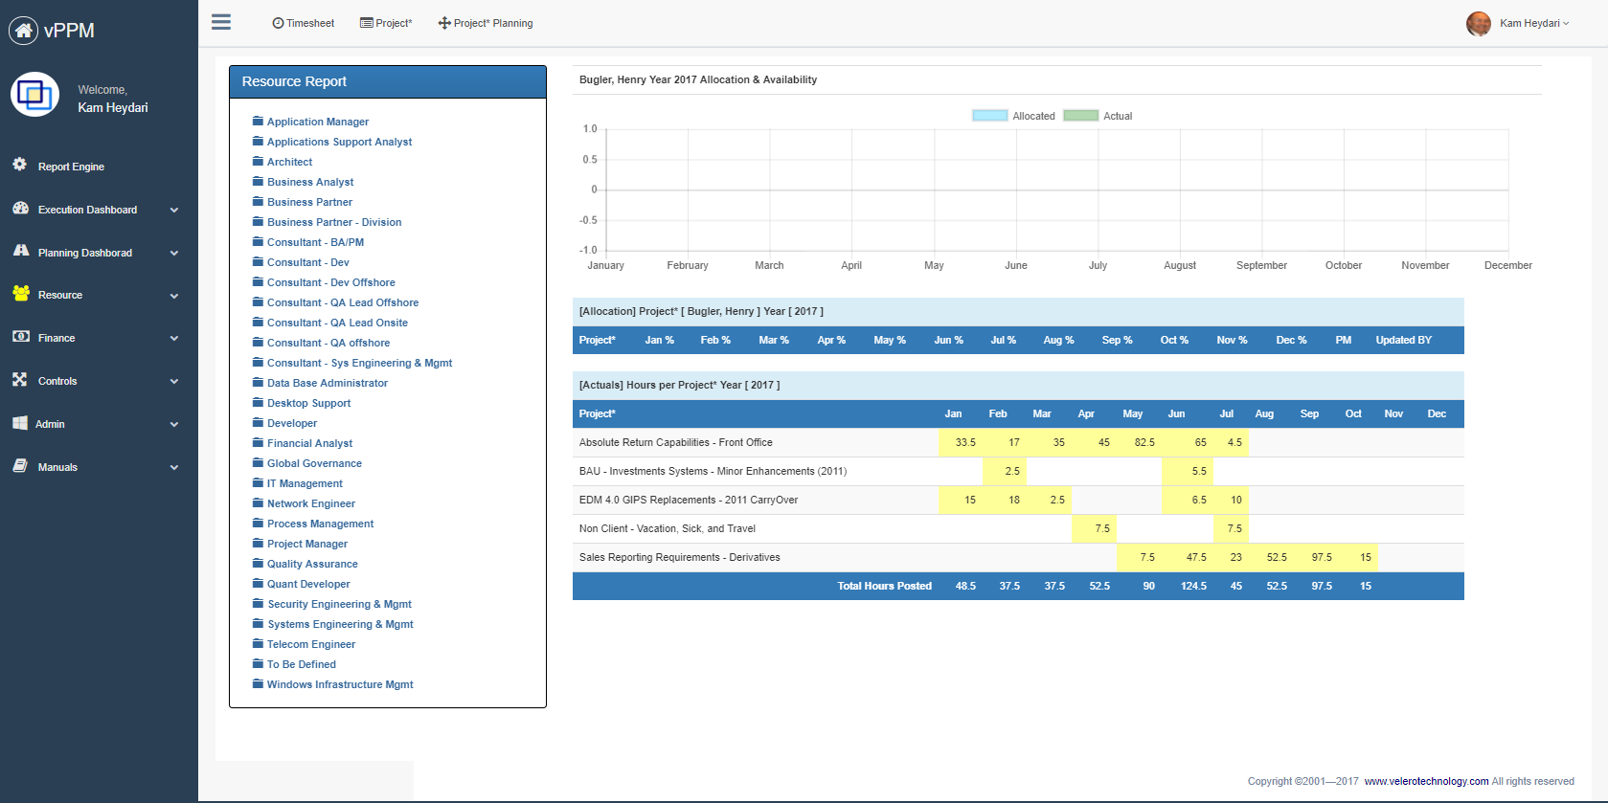

**Student Names:**

Name : Jay Parekh

**Assignment Name:**

Individual Project (Charles Schwab)

Contents

2. Company Strategy & Scorecard 2

2.1. Company Background 2

2.2. SWOT Analysis 2

2.3. Scorecard 3

2.4. Reference information 4

3. Project Definition 4

3.1. Project Business Case 4

3.1.1. Project overview 4

3.1.2. Business issues/opportunities 4

3.1.3. Project Business Goals 5

3.2. Primary Project Objectives 5

3.3. Project Benefits 5

3.4. Primary Project Deliverables & Dependencies 6

3.4.1. Project Deliverables 6

3.4.2. Project Interdependencies and Inputs 6

3.5. Project Conditions 7

3.5.1. Assumptions 7

3.5.2. Risks and Issues 7

3.5.3. Project Constrains 7

3.6. Scope 8

3.7. Strategy Matrix 9

3.8. Work Breakdown Structure 10

3.9. Resource and Cost Estimate 10

3.9.1. Cost 10

3.9.2. Resource Needed 11

3.10. Roles & Responsibility Matrix 12

3.11. Project Structure 13

3.12. Resource requirement Matrix 14

3.13. Project Schedule 15

# Company Strategy & Scorecard

Company Name: Charles Schwab

## Company Background

**Founding Vision and Evolution**: Founded with the idea of making financial markets accessible to the common man, Charles Schwab has continuously evolved to integrate more comprehensive financial services.

**Strategic Acquisitions**: Over the years, Schwab has strategically acquired various companies to broaden its service offerings and expand its market reach.

**Technological Advancements**: Pioneering online trading, the firm continues to invest in technology to lead innovations in the brokerage industry.

## SWOT Analysis

|  |  |
| --- | --- |
| Strength   * Innovations in financial services * Strong emphasis on client-oriented service * Extensive range of investment products * Robust Technological Infrastructure * Customer Trust | Weakness   * Dependence on the U.S. market * Challenges in adapting quickly to new technological advances * Regulatory and Legal Risks * Scaling Customer Service * Pricing Competition * Reliance on Interest Rates |
| Opportunity   * Growing Demand for Financial Literacy * Expansion into Global Markets * Innovation in Financial Products * Demographic Shifts * Regulatory Environment | Treats   * Cybersecurity Risks: * Increasing Regulatory Scrutiny * Intense Market Competition |

## Scorecard

1. Finance Perspective
   1. **Asset Growth**: Aim to grow client assets under management by focusing on demographic trends and personalized service offerings
   2. **Efficiency Ratios**: Improve cost efficiency by optimizing technology and streamlining operations
2. Client Perspective
   1. **Brand Loyalty Programs**: Develop loyalty programs to enhance client retention and attract new clients through referrals.
   2. **Digital Experience Enhancements**: Upgrade digital platforms to provide a seamless, intuitive user experience
3. Product/Service/Process Perspective
   1. **Risk Management**: Enhance risk management frameworks to better cope with market and credit risks.
   2. **Sustainable Practices**: Increase investments in sustainable business practices to attract socially conscious investors.
4. Learning and Growth Perspective
   1. **Technology Training**: Implement ongoing training programs in new technologies and digital tools for employees to keep pace with industry changes
   2. **Diversity and Inclusion**: Strengthen efforts to improve diversity and inclusion within the workforce to foster an innovative and inclusive corporate culture

## Reference information

Citations:

[1] https://www.aboutschwab.com/investor-relations

[2] https://www.aboutschwab.com/financial-reports

[3]https://www.annualreports.com/Company/charles-schwab-corp

# Project Definition

Based on the information regarding your company, SWOT analysis and company strategy, identify a project that your organization can benefit from – **Project selection is limited to technology automation only**. Create project mandate/information create a full project assessment document include required project information.

Project Name: IntelliAdvisor: AI-Enhanced Financial Advisory and Portfolio Management System

## Project Business Case

Create the following information regarding your project:

### Project overview

**Problem**

Charles Schwab faces increasing competition in the financial services industry, particularly from robo-advisors and fintech startups. There's a need to enhance the efficiency and personalization of financial advisory services while maintaining the human touch that clients value. The current system struggles to provide real-time, data-driven insights for advisors and clients, potentially limiting the firm's ability to offer truly personalized investment strategies at a scale.

**Action**

* Build a smart computer system that looks at market trends, client information, and economic news to suggest investments in real-time.
* Use smart technology to automatically adjust investment portfolios and save on taxes.
* Create a system that sends personalized financial tips and alerts to clients.
* Improve Schwab's voice assistant to help clients better.
* Make tools that help advisors spot risks and opportunities in client investments more easily.

**Result**

* Help advisors do 25% more work in the first year by automating routine tasks.
* Make client investments perform 2% better each year on average.
* Make clients 20% happier by giving more personalized and timely financial advice.
* Answer client questions 40% faster using smart voice assistants and automated systems.
* Increase the money Schwab manages for clients by 10% within 18 months by attracting tech-savvy clients and keeping current clients happy.

### Business issues/opportunities

* **Enhance Client Experience and Retention**: By improving the personalization and efficiency of financial advisory services, fostering a deeper and more durable client relationship.
* **Streamline Investment Management Processes**: Utilize advanced AI to better manage portfolios, increasing the efficiency of asset allocations and trading operations, reducing costs.
* **Boost Competitive Edge with Technology**: Adopt cutting-edge technologies in robo-advising and AI to stay competitive against fintech firms and traditional financial institutions.
* **Optimize Regulatory Compliance and Risk Management**: Enhance systems to better manage compliance and risk, protecting against financial crimes and ensuring adherence to financial regulations.

### Project Business Goals

The **IntelliAdvisor** project aims to integrate sophisticated AI technologies to transform and optimize Charles Schwab's financial advisory and portfolio management services. This AI-enhanced system is designed to improve financial outcomes for clients by providing tailored investment strategies, automating routine tasks, and offering real-time, data-driven insights that adjust dynamically to market conditions

|  |  |
| --- | --- |
| ID | Objective/Goal |
| O1 | **Cost Savings:** Implement AI-driven inventory optimization to reduce carrying costs and minimize overstock situations, leading to significant savings in inventory management. |
| O2 | **Decrease needs for manual processing**: Automate inventory tracking and restocking, freeing staff for more important tasks. |
| O3 | **Data-driven decision making**: Leverage AI analytics to provide actionable insights on consumer behavior and demand patterns, enabling more accurate forecasting and strategic inventory placement. |
| O4 | **Customer satisfaction improvement**: Offer smooth shopping across all channels with better product availability and quicker service. |

## Primary Project Objectives

* **Develop AI-Driven Financial Planning Tools**: Tools that utilize AI to predict financial trends and offer personalized investment advice
* **Automate Investment Management:** Use algorithms to automate asset allocation and portfolio rebalancing, enhancing investment precision and efficiency**.**
* **Enhance Client Interaction Through Technology:** Implement advanced CRM systems that use AI to provide clients with timely financial advice and insights.
* **Strengthen Security and Compliance Protocols**: Integrate advanced security measures to safeguard client data and enhance compliance monitoring using AI**.**

## Project Benefits

* **Enhanced Client Satisfaction**: Clients receive more personalized and timely services, increasing satisfaction and loyalty.
* **Reduced Operational Costs**: Automation of routine tasks and enhanced efficiency of investment management processes reduce operational costs.
* **Improved Compliance and Risk Management**: Advanced analytics and real-time monitoring improve the firm’s ability to manage and mitigate risks, ensuring compliance with regulations.
* **Increased Market Competitiveness**: By leveraging state-of-the-art AI, Schwab can enhance its market position by offering superior, technologically advanced services to clients.

## Primary Project Deliverables & Dependencies

These deliverables are drawn from the project’s goals and objectives.

### Project Deliverables

|  |
| --- |
| Deliverable: AI-Driven Financial Planning Tool |
| * Uses machine learning algorithms to analyze client financial data. * Provides personalized investment advice based on market conditions. * Automates routine advisory tasks to save time for human advisors. |
| Deliverable: Automated Investment Management System |
| * Implements automated asset allocation and portfolio rebalancing. * Ensures precision and efficiency in investment decisions |
| Deliverable: Enhanced Client Interaction Tools |
| * AI-powered CRM to deliver timely, personalized financial tips. * Integrates advanced voice assistants for quicker query resolution |

### Project Interdependencies and Inputs

|  |
| --- |
| Project Interdependencies and Inputs |
| * **Technological Infrastructure**: The implementation relies on Charles Schwab’s existing technological infrastructure, including AI capabilities, data analytics tools, and cybersecurity measures. * **Data Availability**: The accuracy of financial advice and portfolio management depends on real-time access to client financial data, market trends, and regulatory updates. * **Human Resources**: Collaboration between the tech team, compliance officers, and financial advisors is essential for seamless integration of AI tools. |

## Project Conditions

The project conditions for the IntelliAdvisor system encompass several aspects including available resources, project delivery timelines, budget constraints, and compliance with financial regulations. The success of the project depends on seamless integration with current technological infrastructure, timely access to data, and the availability of skilled personnel. The project also faces external conditions like market volatility, cybersecurity threats, and evolving regulatory requirements that must be considered throughout the project's lifecycle.

### Assumptions

| **ID** | **Item** |
| --- | --- |
| A1 | Sufficient skilled professionals, including AI experts and financial advisors, will be available throughout the project. |
| A2 | Schwab’s current systems, like CRM and portfolio management, can be seamlessly integrated with new AI tools |
| A3 | Data security measures are robust enough to handle sensitive financial information without causing delays or breaches. |
| A4 | No major changes in financial regulations are expected during the project, so it can proceed without needing big adjustments |

### Risks and Issues

|  |  |  |  |
| --- | --- | --- | --- |
| **Risk** | **Prob** | **Impact** | **Mitigation** |
| AI system may fail to provide accurate financial advice due to data quality issues. | Medium | High | Ensure regular data audits and AI model validation |
| Failure to comply with financial regulations due to automated systems not recognizing legal updates | Medium | Medium | Regular compliance checks and integration with regulatory monitoring tools |
| Unforeseen market volatility could undermine AI-driven investment strategies | High | High | Design AI models to adjust strategies dynamically based on market conditions |

### Project Constrains

* **Time Constraint**: Project must be completed within 18 months to remain competitive in the financial advisory market.
* **Budget Constraint**: The project must not exceed a pre-defined budget set by Schwab’s leadership.
* **Regulatory Compliance**: Must adhere to all financial regulations and ensure client data protection.

## Scope

Define what is in- and out- of scope for your project.

### In scope

| **ID** | **Type** | **Definition** |
| --- | --- | --- |
| S1 | Development and Integration of AI Tools: | The project will include the development and integration of AI-driven financial planning tools and automated investment management systems. This involves algorithm design, implementation, and the integration of these systems into Charles Schwab's existing infrastructure |
| S2 | Customer Relationship Management (CRM) Enhancements | Enhancements to the CRM systems to leverage AI for better client interaction and service. |
| S3 | Compliance and Security Upgrades | Enhancements to compliance monitoring and security protocols to handle increased data processing and storage needs due to the new AI capabilities |

### Out of Scope

| **ID** | **Type** | **Definition** |
| --- | --- | --- |
| S1 | Overhaul of Existing IT Infrastructure | Complete overhaul of current IT systems is out of scope. The project will utilize existing IT infrastructure with necessary upgrades to support new functionalities. |
| S2 | Physical Infrastructure | No new physical infrastructure, such as new office buildings or data centers, will be developed as part of this project. |
| S3 | Non-AI Related Business Service | Development of new financial products or services that do not directly involve the AI enhancements described are out of scope |

## Strategy Matrix

Define complete strategic matrix for your project using strategic matrix table – Identify 4 strategies for the organization – See lecture material and PMI material.

|  |  |  |  |  |  |  |
| --- | --- | --- | --- | --- | --- | --- |
| |  | | --- | | **Project Objectives from Scorecard** |  |  | | --- | |  | | Build Automation | Enhanced App Interface | Seamless System Integration | Personalized Insights |
| |  | | --- | | **Asset Growth** |  |  | | --- | |  | | |  | | --- | | Yes |  |  | | --- | |  | | |  | | --- | | No |  |  | | --- | |  | | |  | | --- | | Yes |  |  | | --- | |  | | |  | | --- | | Yes |  |  | | --- | |  | |
| |  |  |  | | --- | --- | --- | | |  | | --- | | **Efficiency Ratios** |  |  | | --- | |  | |  |  | | --- | |  | | |  | | --- | | Yes | |  |  |  | | --- | |  | | |  | | --- | | No |  |  | | --- | |  | | |  | | --- | | Yes |  |  | | --- | |  | | |  | | --- | | No |  |  | | --- | |  | |
| |  |  |  | | --- | --- | --- | | |  | | --- | | **Brand Loyalty** |  |  | | --- | |  | |  |  | | --- | |  | | No | Yes   |  | | --- | |  | | |  | | --- | |  |   No | |  | | --- | |  |   Yes |
| |  |  |  | | --- | --- | --- | | |  | | --- | | **Digital Experience Enhancements** |  |  | | --- | |  | |  |  | | --- | |  | | |  | | --- | | No | |  |  |  | | --- | |  | | |  | | --- | | Yes | |  |  |  | | --- | |  | | |  | | --- | | Yes |  |  | | --- | |  | | Yes |
| |  | | --- | | **Risk Management** |  |  | | --- | |  | | Yes | No | Yes | No |
| |  | | --- | | **Sustainable Practices** |  |  | | --- | |  | | No | No | No | Yes |

## Work Breakdown Structure

Define your work breakdown structure for your project – See Lecture material

## Resource and Cost Estimate

Using the following format define your resource (Excluding FTE Cost) cost estimates.

### Cost

|  |  |  |
| --- | --- | --- |
| Cost Description | Amount | Note |
| **Project Manager** | **$150,000** | Responsible for overseeing the project from initiation through completion. Manages the project's schedule, resources, budget, and risk. Ensures the project meets its objectives and is delivered on time and within budget |
| **Systems Architect** | **$180,000** | Designs the overall system architecture for the IntelliAdvisor platform, ensuring it is scalable, secure, and integrates seamlessly with existing Charles Schwab systems.. |
| **Application Engineer** | **$130,000** | Fees for external consultants to assist with system integration, project management, and training for staff on new inventory management processes. |
| **Data Engineer** | **$140,000** | Budget for training programs and workshops to educate employees on using the new Automated Inventory System and dashboard functionalities. |
| **Data Analyst** | **$120,000** | Reserved for unexpected expenses related to project delivery, including additional software requirements or changes in scope. |
| **IT Support Staff** | **$90,000** | Essential software for data encryption, access control, and intrusion detection to ensure the security of inventory and sales data. |
| **Security Engineer** | **$160,000** | Focuses on safeguarding all systems against cybersecurity threats and ensuring compliance with financial and data protection regulations |
| **Test Engineer** | **$120,000** | Responsible for planning and conducting tests to ensure the software meets its design specifications and is free of defects |
| Total | **$1,090,000** |  |

### Resource Needed

|  |  |
| --- | --- |
| Resource Type | Note |
| **Project Manager** | Oversees the entire project, managing timelines, budgets, and resource allocation. Ensures project objectives are met. |
| **Systems Architect** | Designs and oversees the implementation of the overall system architecture, ensuring scalability, security, and integration with existing systems. |
| **Application Engineer** | Develops the AI-driven financial planning and investment management tools. Works on coding, testing, and deploying software updates. |
| **Data Engineer** | Manages data architecture and ensures data quality and security. Supports AI model development with appropriate data infrastructure. |
| **Data Analyst** | Analyzes data outputs from AI models, providing insights that inform financial advice and system improvements. |
| **IT Support Staff** | Maintains and troubleshoots IT systems and software, ensuring continuous operation and addressing technical issues |
| **Security Engineer** | Implements security measures, monitors systems for security breaches, and ensures compliance with regulatory requirements. |
| **Test Engineer** | Designs and executes tests to ensure software functionality and performance. Identifies bugs and issues prior to deployment. |

## Roles & Responsibility Matrix

Define roles and responsibilities using RACI model for all participating resources.

|  |  |  |  |  |  |  |  |  |  |
| --- | --- | --- | --- | --- | --- | --- | --- | --- | --- |
| **Project Team**  **Area of Responsibilities** | | **Project Manager** | **Machine Learning**  **Engineer** | **IT systems**  **Administrator** | **Data Scientist** | **UI/UX**  **Designer** | **Retail**  **Operations**  **Expert** | **QA**  **Tester** | **Cyber**  **Security**  **Analyst** |
| **Define Project Objectives** |  | A | C | I | C | C | C | I | I |
| **Develop**  **AI**  **Algorithm** |  | I | R | C | C | I | I | C | C |
| **Integrated AI Tools**  **With Infra** |  | C | C | R/A | I | I | I | I | C |
| **Design user**  **interfaces** |  | C | C | I | I | R/A | C | I | I |
| **Analyze data for insights** |  | C | C | I | R/A | I | I | I | I |
| **Develop compliance and security** |  | I | C | I | I | I | I | I | R/A |
| **Conduct quality assurance testing** |  | I | I | I | I | I | I | R/A | C |
| **Provide**  **Operational**  **Guidance** |  | I | I | I | I | I | R/A | I | I |
|  |  | R | A | C | I |  |  |  |  |
|  |  |  |  |  |  |  |  |  |  |
| **Responsible** | | People or stakeholders who are the "doers" of the work. They must complete the task or objective or make the decision. Several people can be jointly *Responsible*. | | | | | | | |
| **Accountable** | | Person or stakeholder who is the "owner" of the work. He or she must sign off or approve when the task, objective or decision is complete. This person must make sure that responsibilities are assigned in the matrix for all related activities. ***Success requires that there is only one person Accountable.*** | | | | | | | |
| **Consulted** | | People or stakeholders who need to give input before the work can be done and signed-off on. These people are "in the loop" and active participants. | | | | | | | |
| **Informed** | | People or stakeholders who need to be kept "in the picture." They need updates on progress or decisions, but do not need to be formally consulted, nor do they contribute directly to the task or decision. | | | | | | | |

## Project Structure

Define your project structure considering information provided in the project mandate.

## Resource requirement Matrix

Define resource requirement matrix per work pages using the format that was provided to you in the class and for your group assignment.

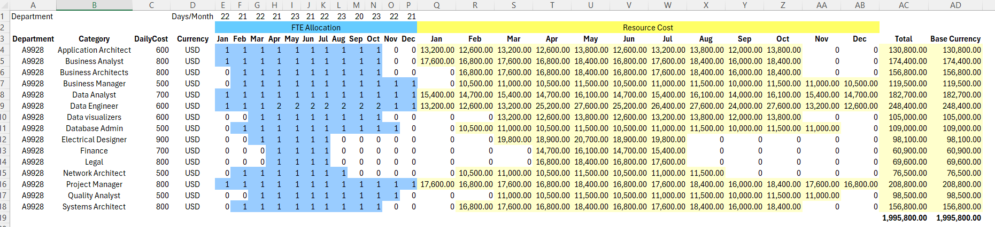

Using Velero product include the estimated cost (Screenshot)

## Project Schedule

